BlockPay
Solidity Blockchain Dev

Student name | Email | Github repo link
Jovan Lukovic | lukovicjovan45@gmail.com | https://github.com/JoWan2908/Blochchain-projects.git

Content
1 Application Description 3
2 Implementation 3
2.1 List of Functions 3
2.2 Events & Validations 3
3 Testing 3

Application Description
Describe the purpose and overall functionality of the application and the purpose of the smart contract.
Purpose: The purpose of the BlockPay application is to implement a transparent, decentralized, and automated system for labor tracking and salary distribution within an organization. By utilizing smart contracts on the Ethereum blockchain, the application eliminates the need for intermediaries (banks) and manual payroll calculations, drastically reducing the possibility of human error or data manipulation.
Overall Functionality: The application operates through two interconnected modules:
- FirmaManager (Administrative Module): The company director (owner) uses this contract to register new employees (creating their profiles) and execute payments to those specific profiles.
- RadnikProfil (User Module): Every worker receives a unique smart contract that serves as a personalized attendance system (check-in/check-out). They can also withdraw the funds sent by director manually to their private wallet.

Implementation

List of Functions

Contract: FirmaManager
- registrujRadnika
  - Input parameters: address _radnik (worker's wallet address), string memory _ime (worker's name), uint _satnica (hourly/per-second rate).
  - Return type: N/A
  - Access modifier: public (protected by a require check restricted to the director).
  - Description: Deploys a new instance of the RadnikProfil contract for a specific worker and stores the mapping between the worker's wallet and their contract address.
- isplatiRadnika
  - Input parameters: address _radnik (the public wallet address of the registered worker).
  - Return type: N/A
  - Access modifier: public payable (allows sending Ether along with the function call).
  - Description: Transfers the specified amount of Ether from the director's wallet to the worker's specific RadnikProfil contract.

Contract: RadnikProfil
- prijaviDolazak (Check-in)
  - Input parameters: N/A
  - Return type: N/A
  - Access modifier: public (restricted to the profile owner via require check).
  - Description: Records the current block timestamp as the start of the work shift.
- odjaviSe (Check-out)
  - Input parameters: N/A
  - Return type: N/A
  - Access modifier: public (restricted to the profile owner).
  - Description: Calculates the time elapsed since check-in, updates the ukupnaZarada (total earnings) based on the rate, and resets the session.
- podigniPlatu (Withdraw)
  - Input parameters: N/A
  - Return type: N/A
  - Access modifier: public (restricted to the profile owner).
  - Description: Transfers the entire accumulated Ether balance from the contract to the worker's personal wallet address.

Events & Validations
Events:
- IsplataIzvrsena(address indexed radnik, address ugovor, uint iznos): Emitted within the isplatiRadnika function. It logs every payment on the blockchain, allowing external applications to easily track and display payment history.
Validations (require):
- Authorization: require(msg.sender == direktor/novcanikRadnika) ensures that unauthorized parties cannot trigger payments or falsify work hours.
- State Check: require(vremeDolaska > 0) in the odjaviSe function prevents calculation errors if a worker hasn't previously checked in.
- Financial Security: require(iznos > 0) in podigniPlatu prevents unnecessary gas consumption if the contract balance is empty.
- Transfer Confirmation: require(success/uspeh) verifies that the Ether has successfully left the contract and reached the intended destination.

Testing
Screenshots from Remix showing:
- Contract compiled successfully
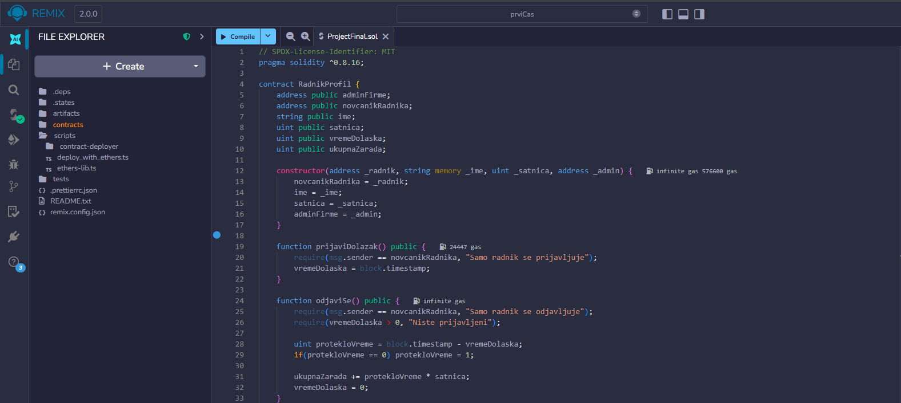

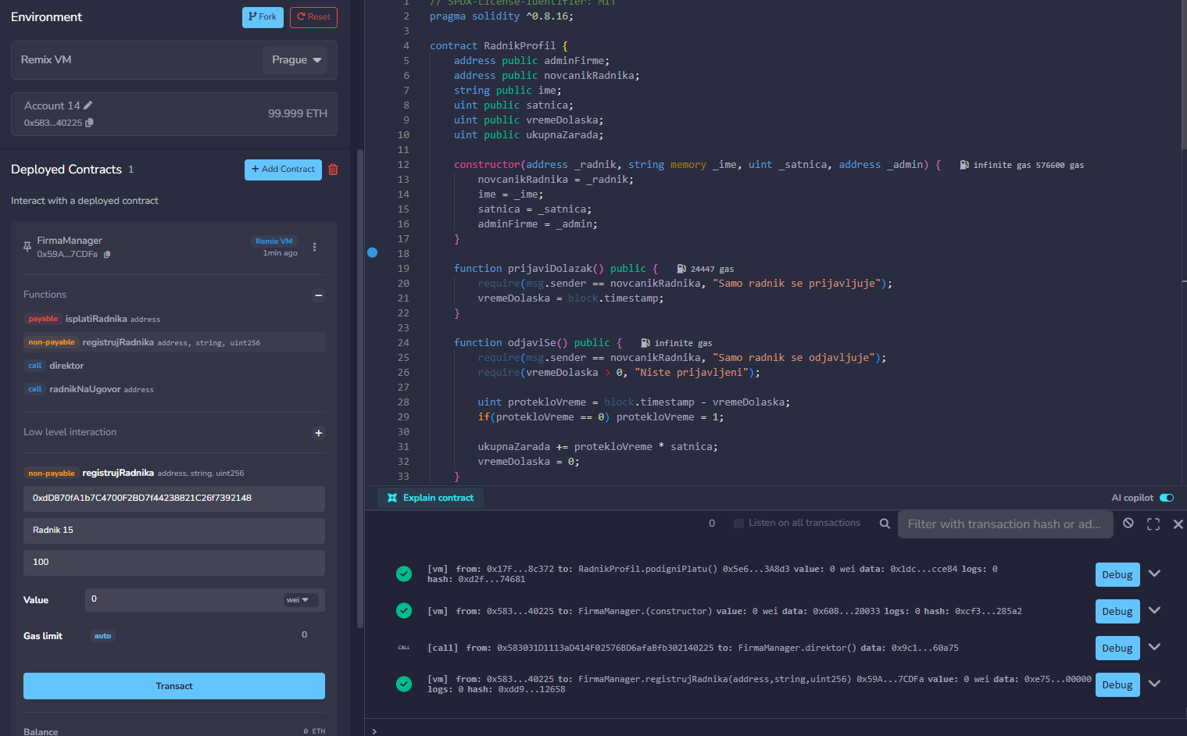
- Two functions being called with visible results
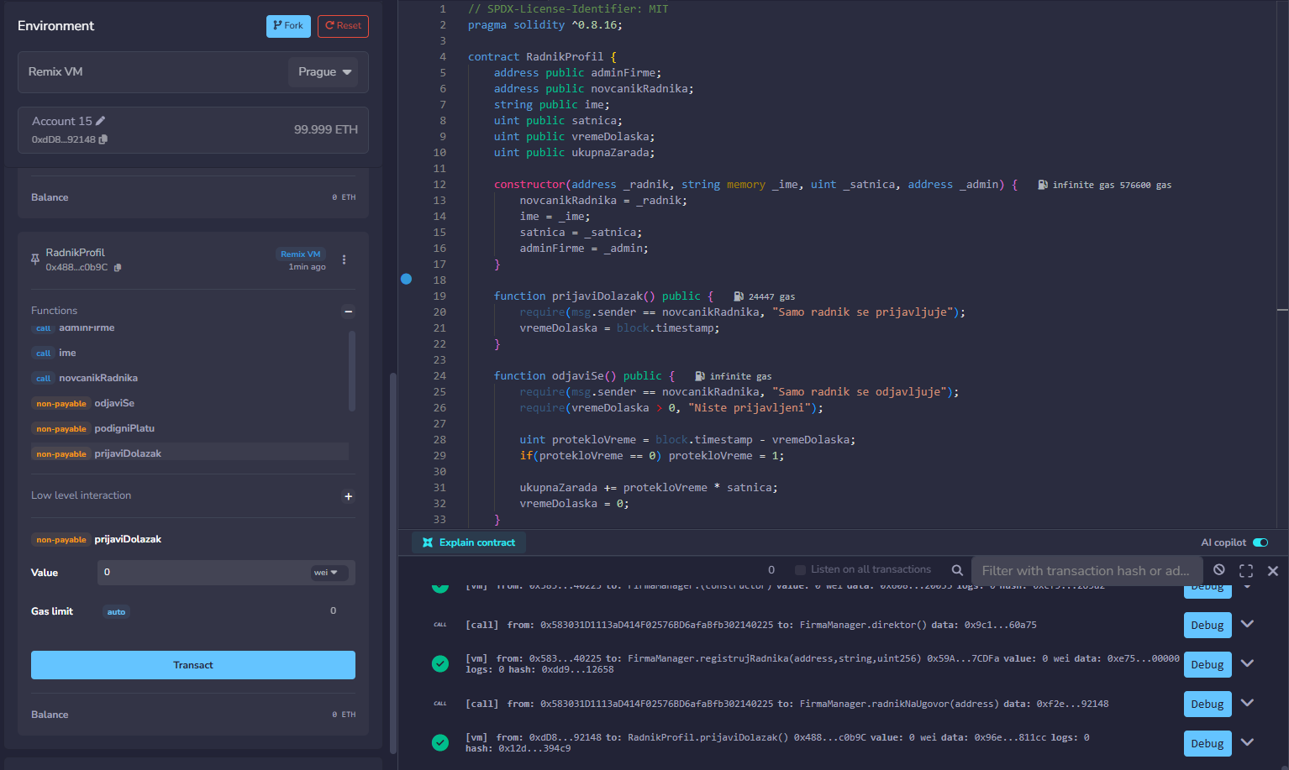
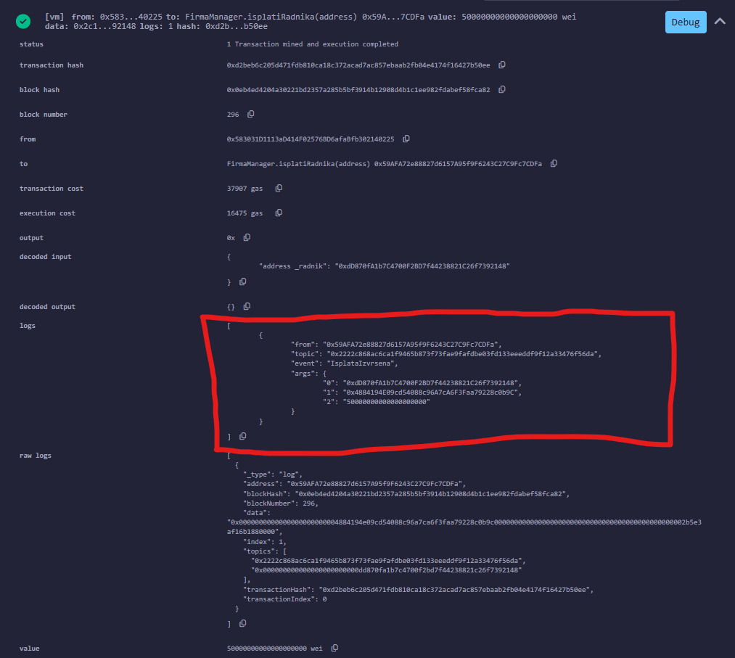
- Event being emitted (e.g. in the Remix console)

Screenshots from the http://sepolia.etherscan.io/ showing the transactions regarding:
- Smart contract deployment
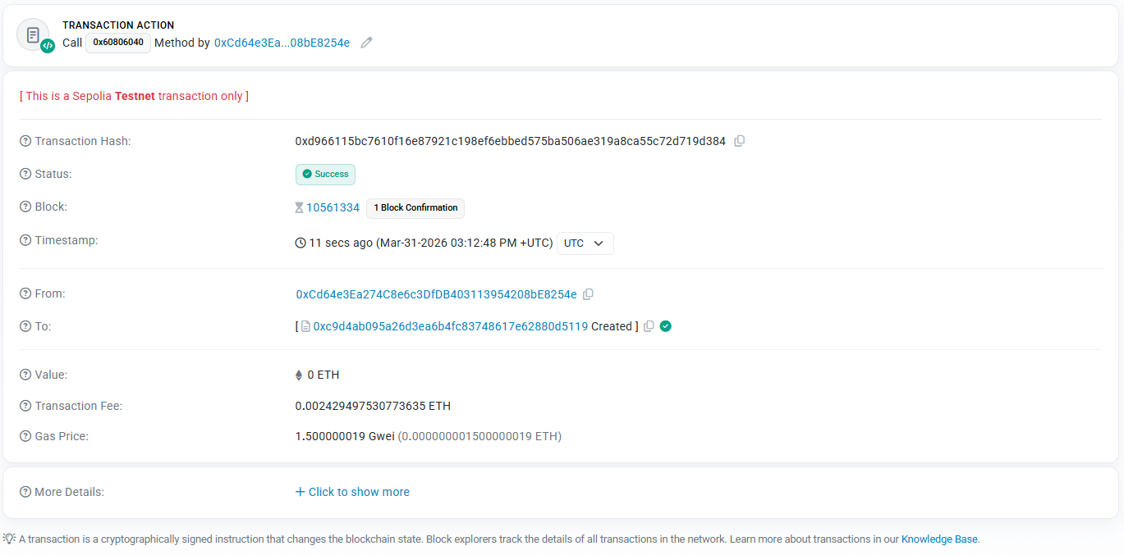
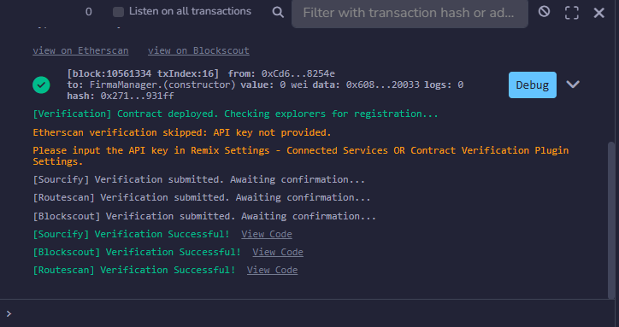

- Smart contract interaction
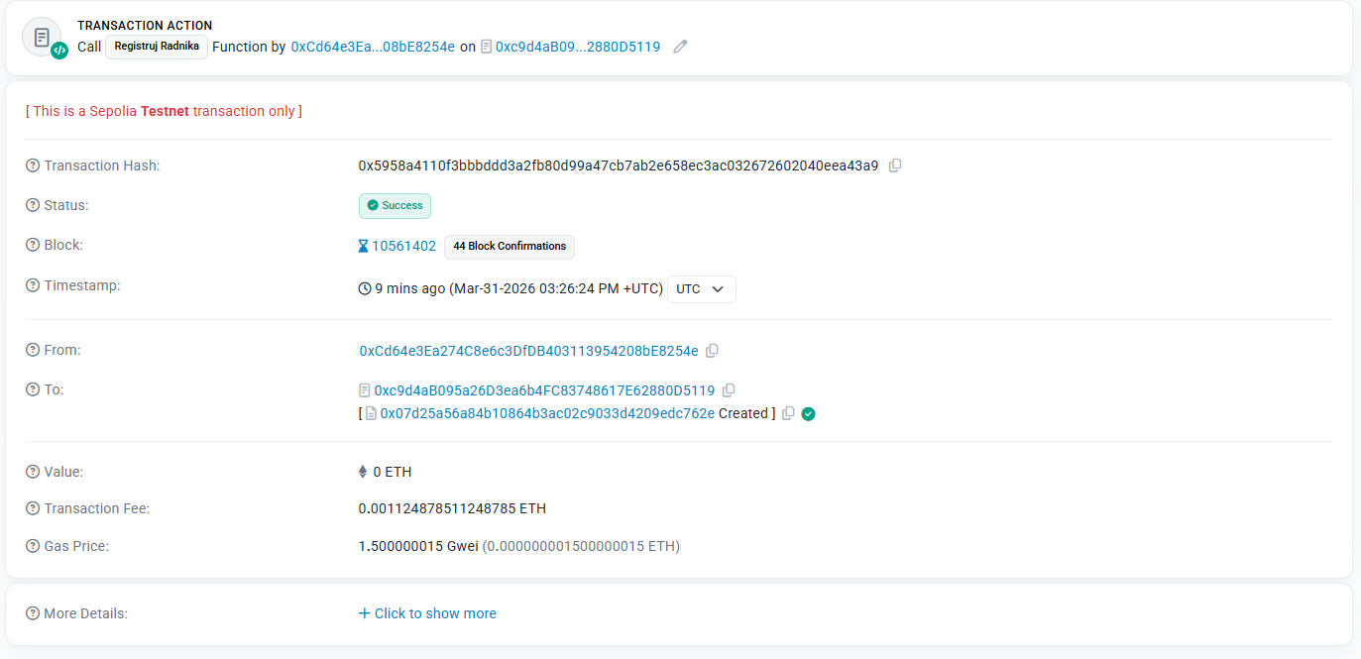
Prijava radnika (iznad)
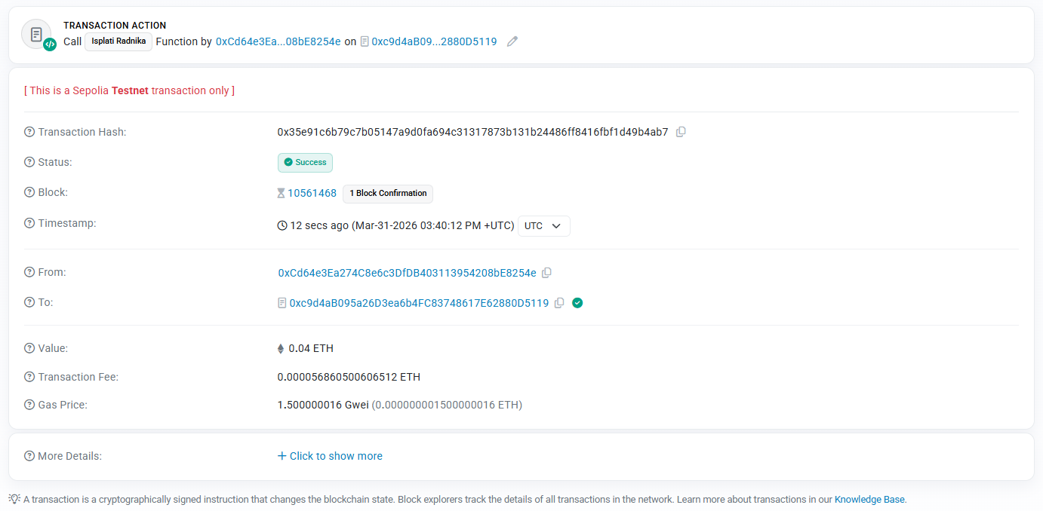
Poslali smo dva puna po 0.04 eth nasem radniku cija je adresa na nasem drugom metamask nalogu te se njegovo stanje na racunu menja, sto pokazuje jednu od interakcija naseg smart contracta preko Menazera Firme i funkcije isplati radnika.

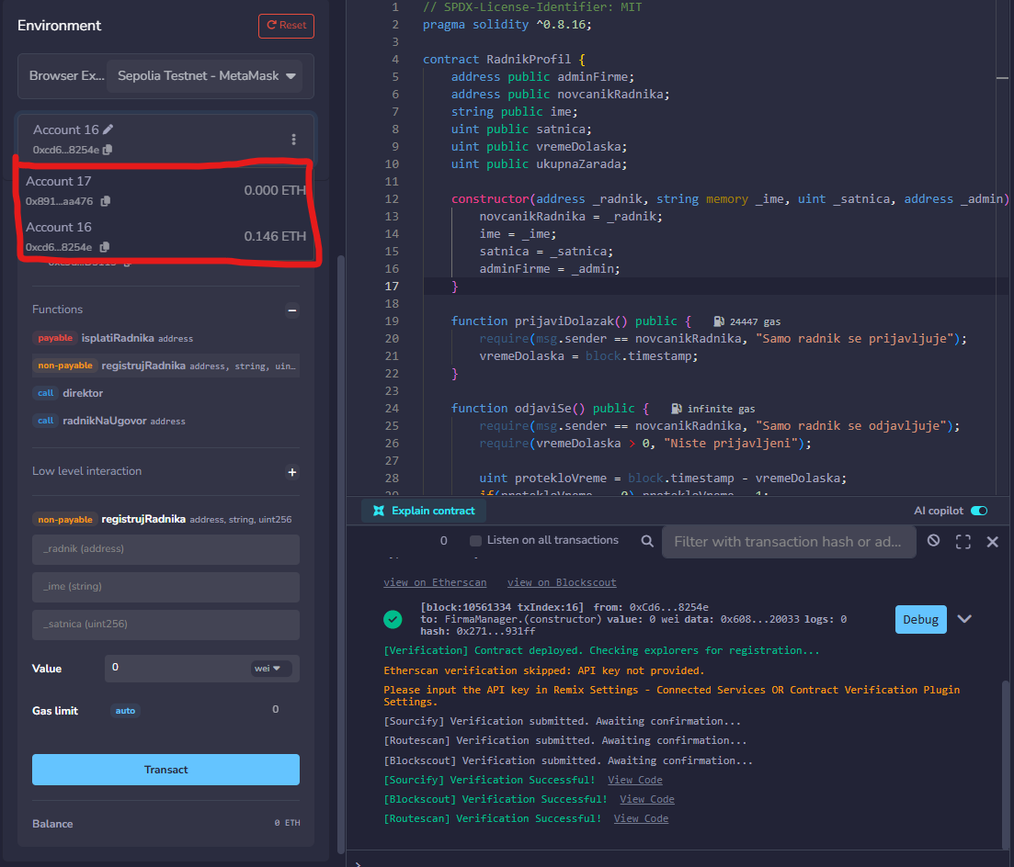
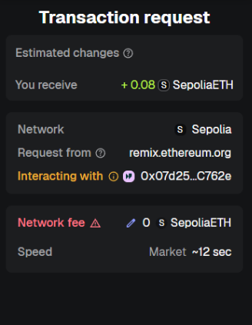
Pre interakcije balans stanja izgleda ovako, a kada se korisnik uloguje na svoj ugovor i podignePlatu balans stanja se menja i novac biva uplacen na adresuRadnika. Te na kraju Radnik prima sredstva kao na slici dole.

